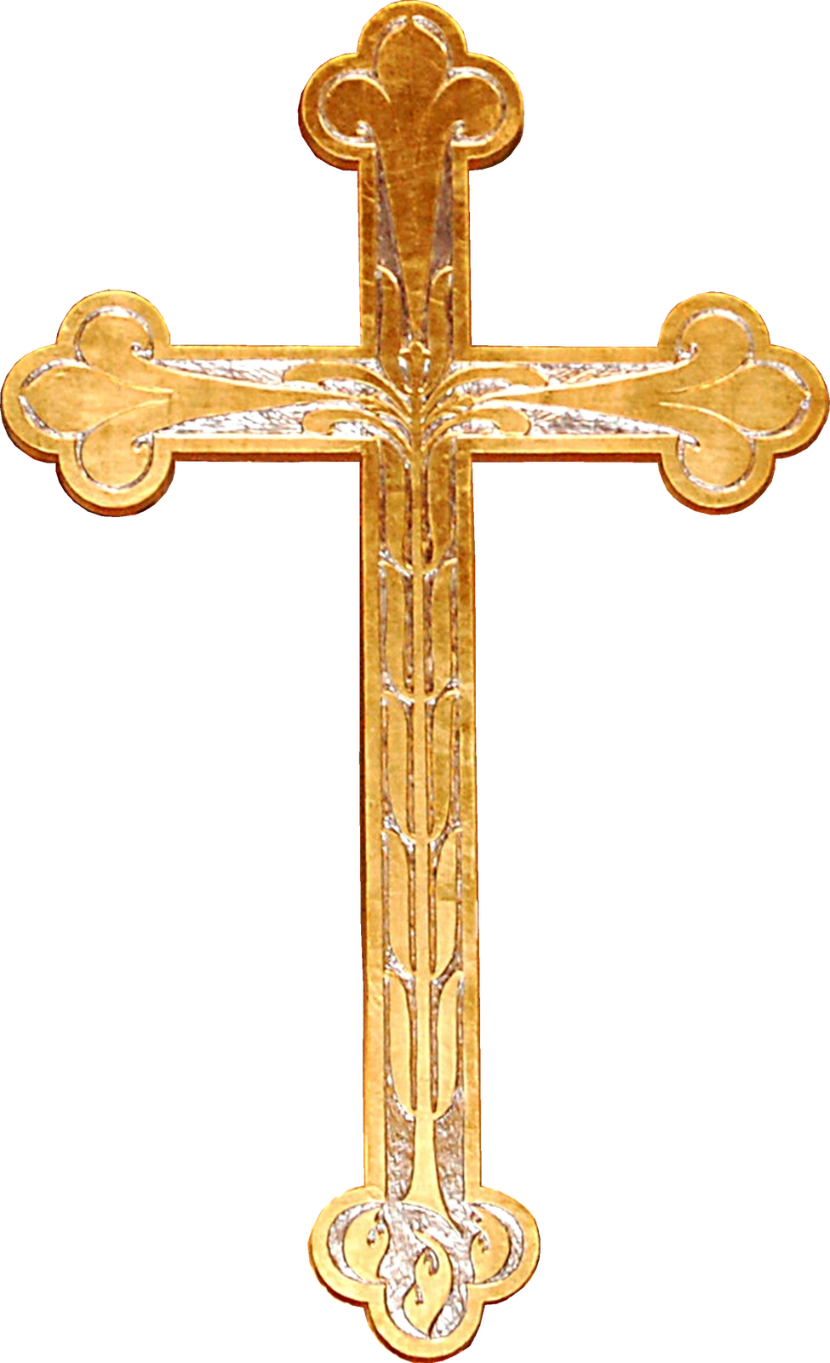

**Holy Day of Obligation The Commemoration of all the faithful**

**All Saints Day ~~Volunteers please departed. All the Souls Day**

**November 1st, Wednesday** 7:00am & 6:30pm **November 2nd, Thursday** 7:00am

**4:00pm Saturday November 4 8:00am Sunday November 5 9:30am Sunday November 5**

**S**– Kendol Benes/Hunter Benes Colton Dubas/Volunteer Quentin Jano/Owen Jano

**A**-Mike Masek Luke Benes Gary Rezac

**R**-Paula Masek Kevin Henrichson Billie Kollars

**U**-Roger Benes/Don Kobza Casey Potter/Scott Benes Kurt Virgil/Andrew Kobza

**U**- and 2 volunteers and 2 volunteers and 2 volunteers **O**-Ken & Clarice Sabata Casey & Jennifer Potter family Effrin & Jenni Jano family

**4:00pm Saturday November 11 8:00am Sunday November 12 9:30am Sunday November 12**

**S**– Cooper Pierce/Bennet Johnson Will Siebrandt/Wyatt Siebrandt Elliot Kalin/Reid Petersen

**A**- Lupe Lopez Adam Benes Todd Fiala

**R**–JoAnn Lopez John Benes Jennifer Benes

**U**–Aaron Pierce/Shane Sisel Cody Siebrandt/Bill Buresh Joe Gyhra/Roger Benes

**U**– and 2 Volunteers and 2 Volunteers and 2 Volunteers

**O**– Aaron & Katie Pierce family Cody & Monica Siebrandt family Joe & Laura Gyhra family

**4:00pm Saturday November 18 8:00am Sunday November 19 9:30am Sunday November 19**

**S**– Carter Chmelka/Eli Benkusky Thomas Potter/Volunteer Aiden Masek/Colin Masek

**A**- John Swanson Casey Potter Ron Regnier

**R**–Deanna Swanson Don Tvrdy Robin Regnier

**U**–Rob Chmelka/Dan Benkusky Terry Chmelka/Robert Rezac Doug Benes/Gary Masek

**U**– and 2 Volunteers and 2 Volunteers and 2 Volunteers

**O**– Rob & Mary Chmelka family Terry & Terri Chmelka Gary & Carol Masek

Thursday, November 23, 2023 Thanksgiving Day Mass 9:00am

**Servers**: Eli Kinkaid/Trent Moudry  **Acolyte:** Bob Rezac **Reader:** Linda Ward

**Offertory**: Mike & Paula Masek

**4:00pm Saturday November 25 8:00am Sunday November 26 9:30am Sunday November 26**

**S**– Ray Dickey/Beckett Zurcher Colton Dubas/Volunteer Owen Korger/Stryker Youngblood

**A**- Mark Sander Glen Masek Jeremy Jordan

**R**–Jennifer Benes Dan Homes Chere Kane

**U**–Chris Dickey/Cameron Fletcher Paul Donahue/Kevin Henrichson Zach Furasek/Ryan Brandt

**U**– and 2 Volunteers and 2 Volunteers and 2 Volunteers

**O**– Barry & Julie Mack Paul & Karri Donahue family Ryan & Meagan Benes family

*If you would like to be added to the offertory list please let me know asap.   
 *If you cannot fulfil your obligation/find a replacement/or switch with someone PLEASE call Paula 402-784-2511 EXT #3.

